# Smsthief No Cover

* 56ee311f1ba520186eb4b0510e7cbe310a855033608a26da088112cd354b6e77

Pack by 360, It can’t be installed in X86 architecture

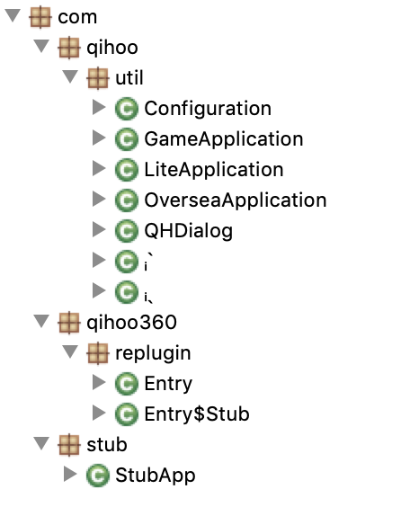 

* 6bab1ada1355bb1bfe17ae7798791052db98e8c9e03ac88734964648db5302ac

Get Contacts/GPS Location

Check server state and network state, and get commands.

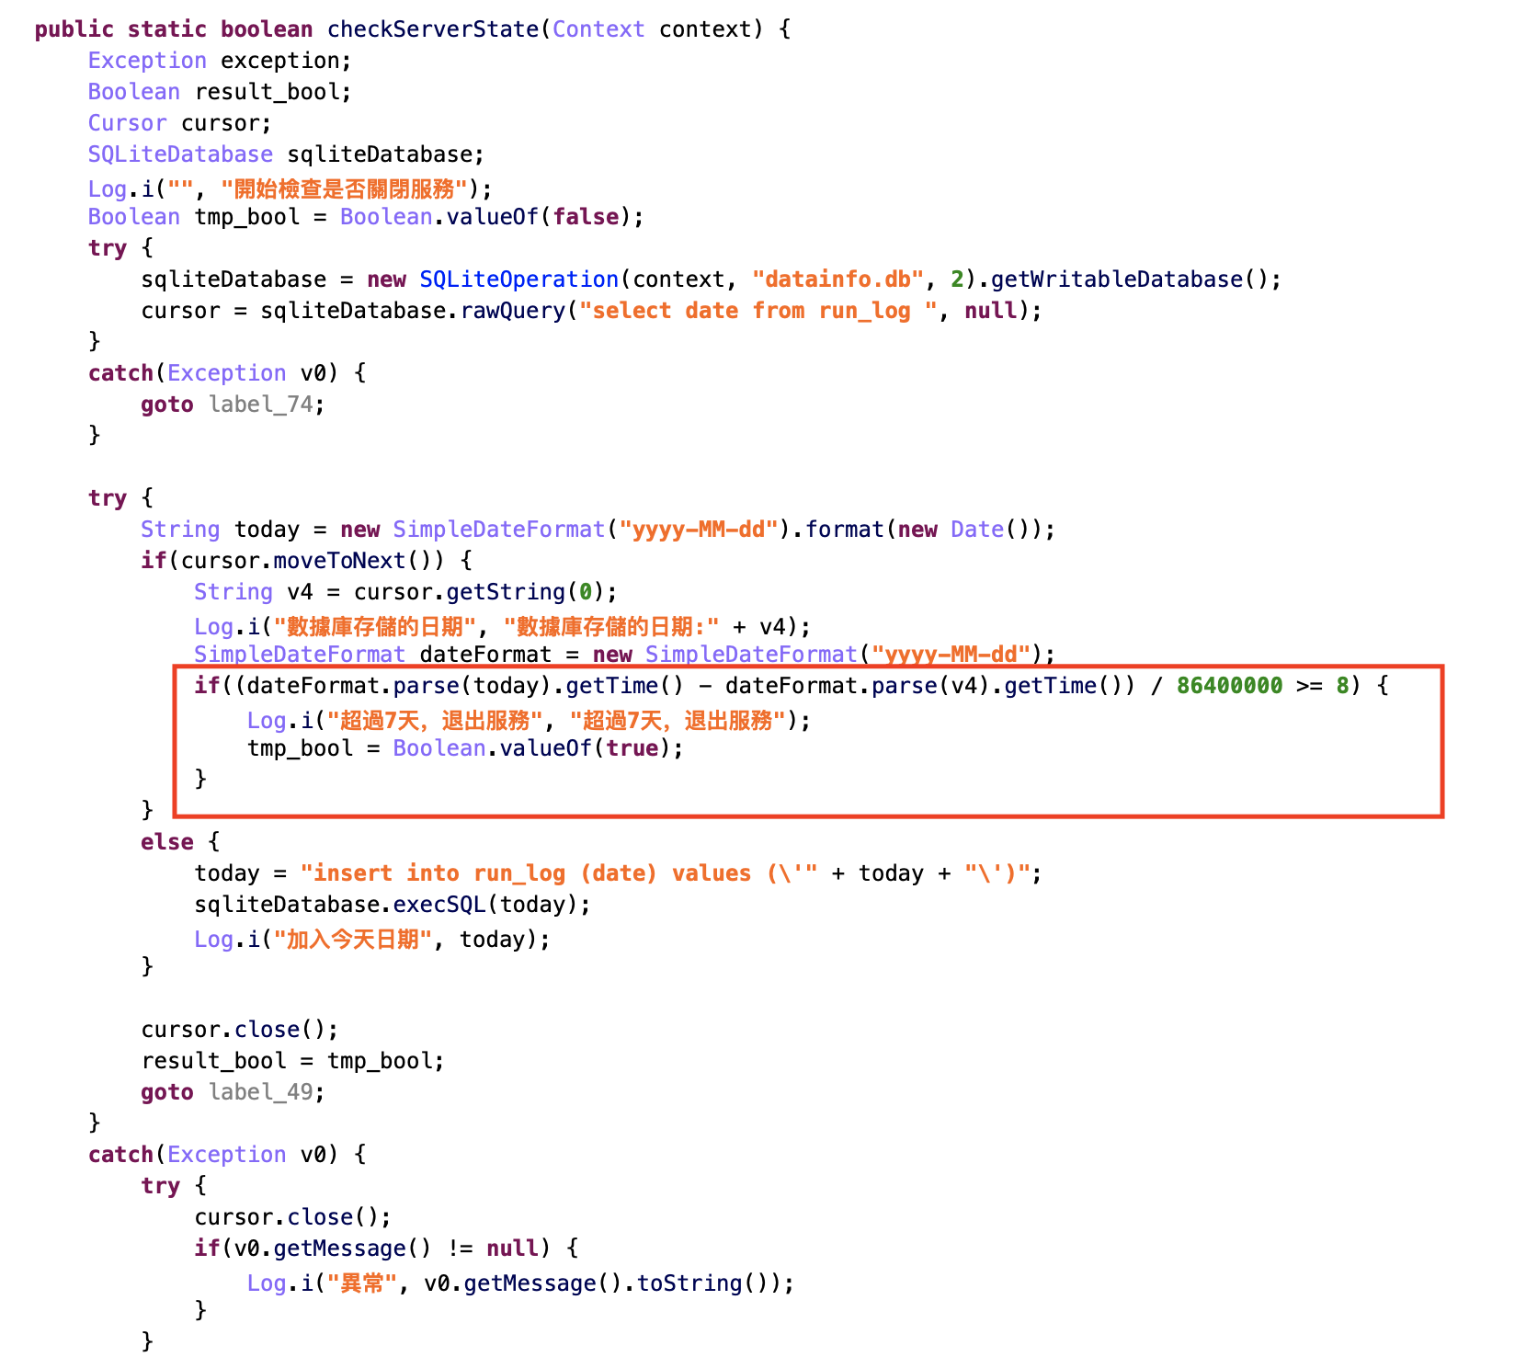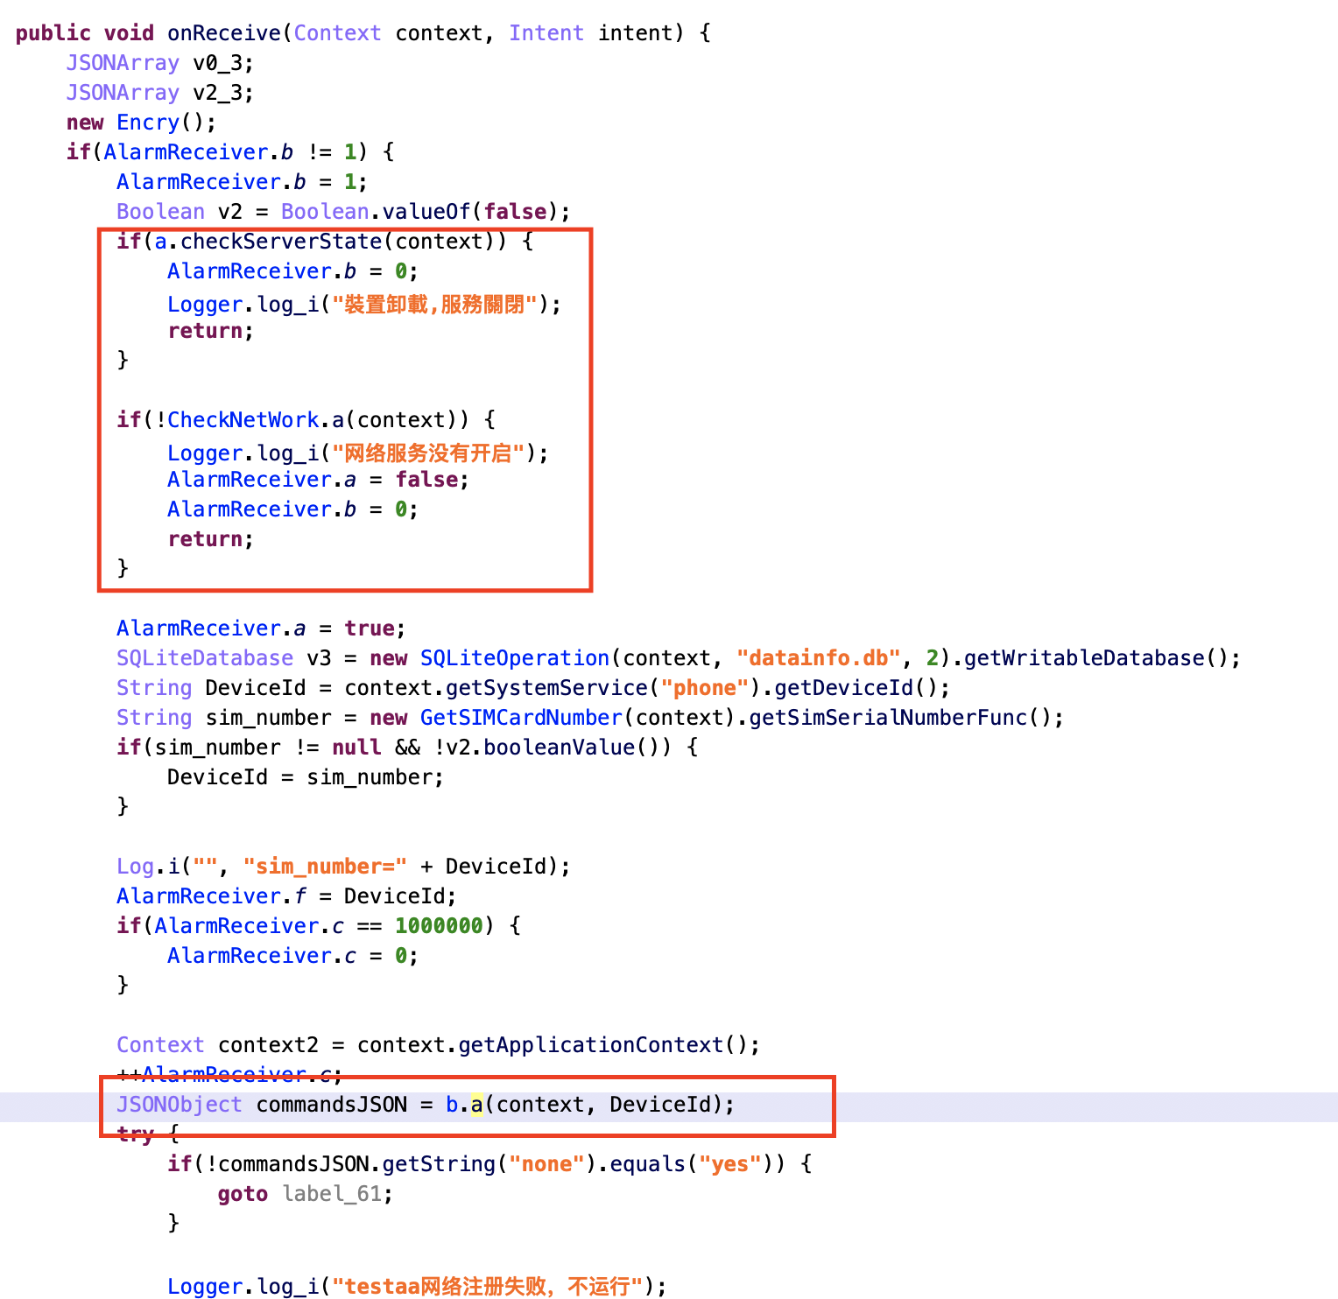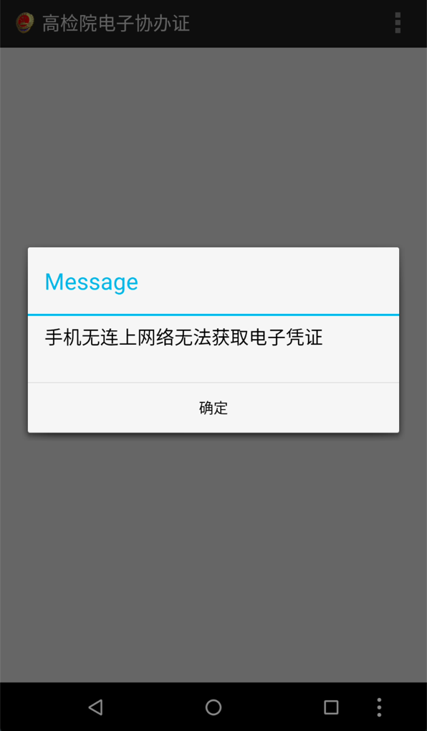

Switch Mobile, replace phone number when the call activity jumps

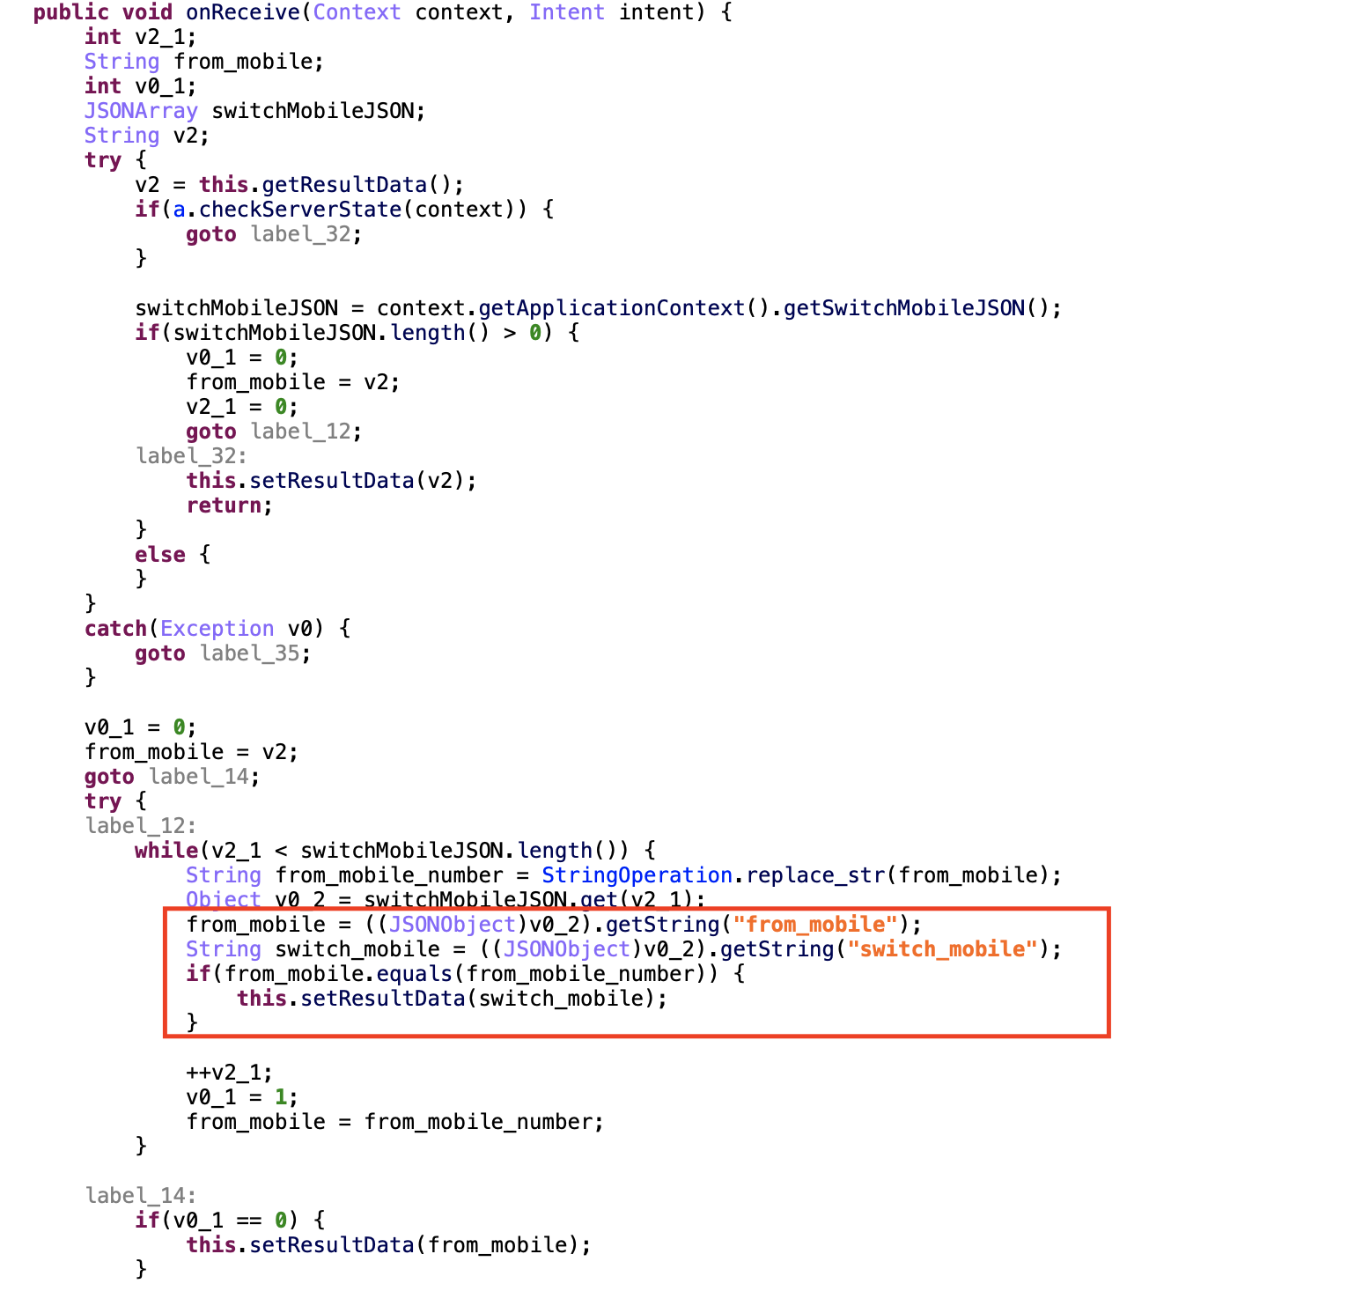

getSystemService(**"notification"**).cancelAll()

Landroid/app/NotificationManager;->cancelAll()V

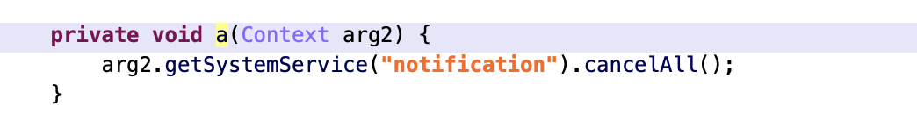

adb shell am broadcast -a android.provider.Telephony.SMS_DELIVER, spoof is failed.

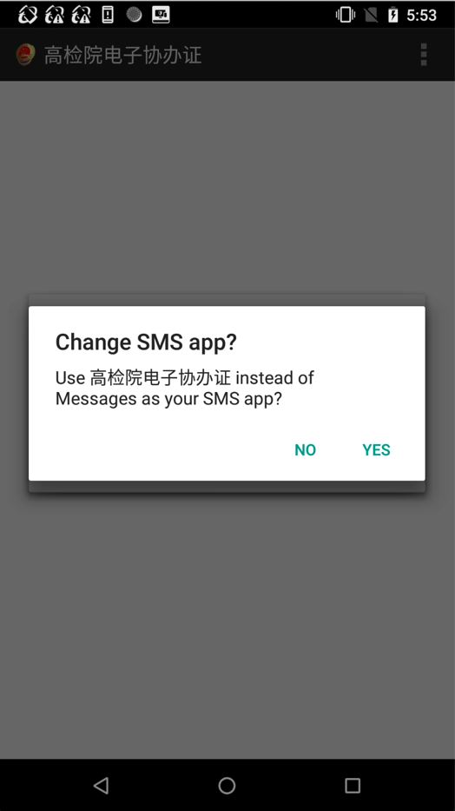

Signature verification failed in Android8.1

Get Device ID when bundle data in Intent.

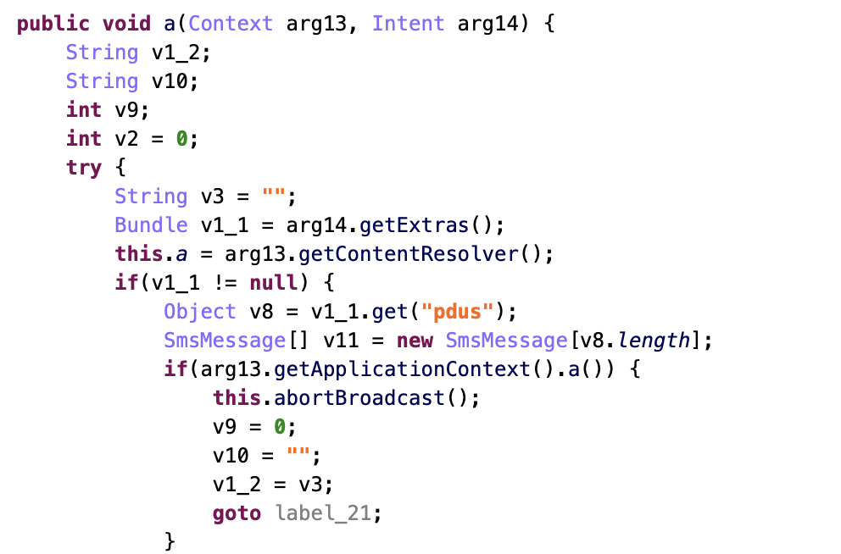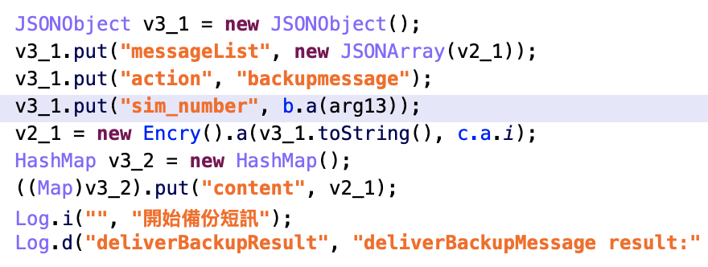

* 3080fa6b0c00dcb34de9ee32dcddc3c0491d3899269af71367e0322cec916787

Can’t start, sandbox evasion

adb shell am start -a android.intent.action.MAIN drogba.ajax/beckham.owen.MainActivity

Disable Receiver and Service

all adb spoof is failed

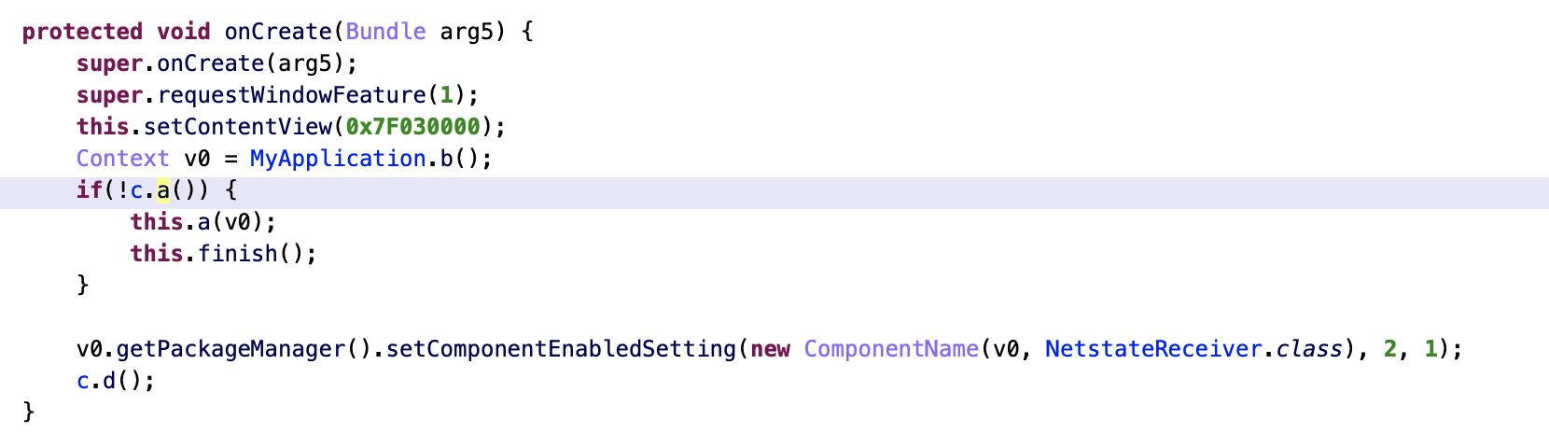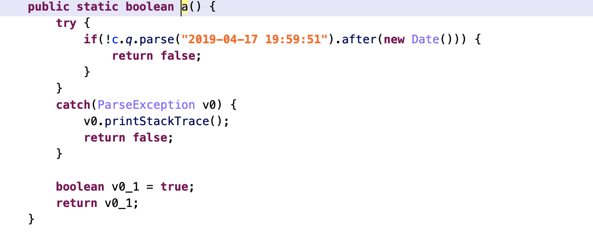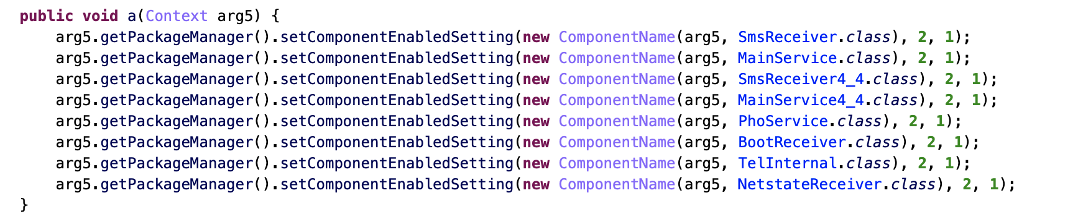

Demo

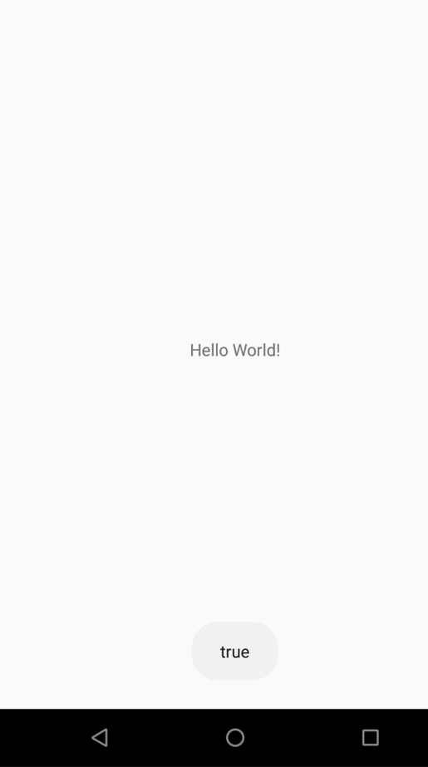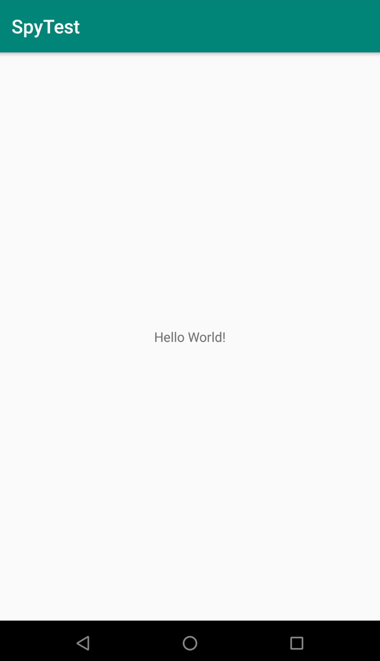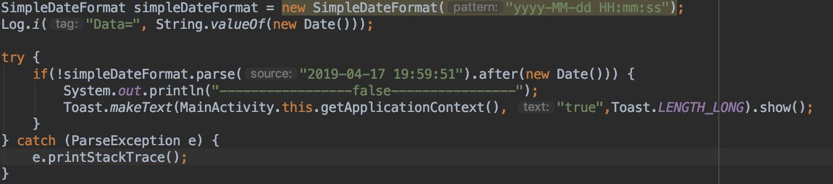

Java.perform(function () {  
 var date = Java.use('java.util.Date');  
   
 date.after.implementation = function(arg1){  
 console.log(arg1);  
 console.log("[+] Java date bypass ");  
 return true;   
 }  
  
});

Bypass sandbox evasion, hook Data.after(Data data)

// Original

public boolean after(Date when) {  
 return *getMillisOf*(this) > *getMillisOf*(when);  
}

//hook

public boolean after(Date when) {  
 return *true*;  
}

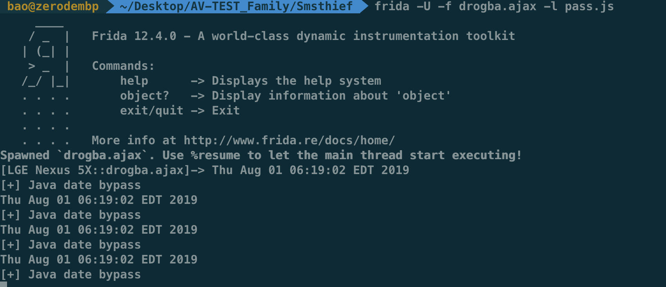 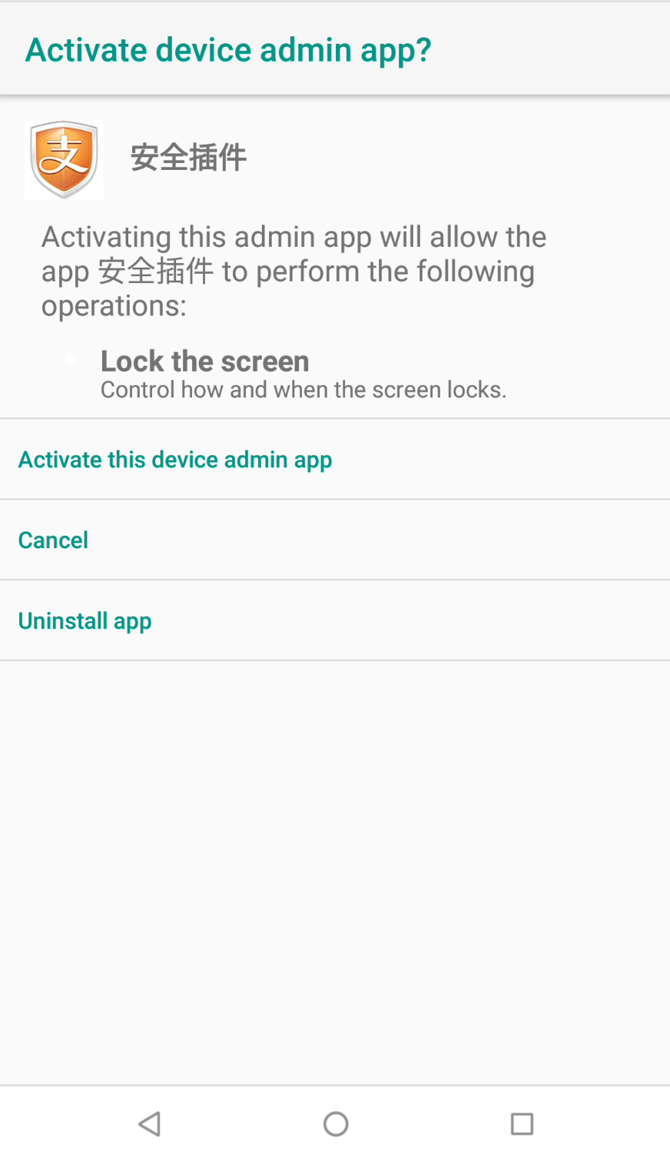

Smart click can touch off device admin action and default sms

* 7a99d5d5dfef2a3f292307daa07b450e4f192899d9d6be1a0b2ae43285f63296
* 8ad94da33af4b959c12248a5a6b2723b81cd67cdd971818eb582b2cd7c81c6cd
* b24a3d0457878e915a3356cd3cde007093b2cc83128f921f5052f1844a0e7c6c

Same as 3080fa6b0c00dcb34de9ee32dcddc3c0491d3899269af71367e0322cec916787

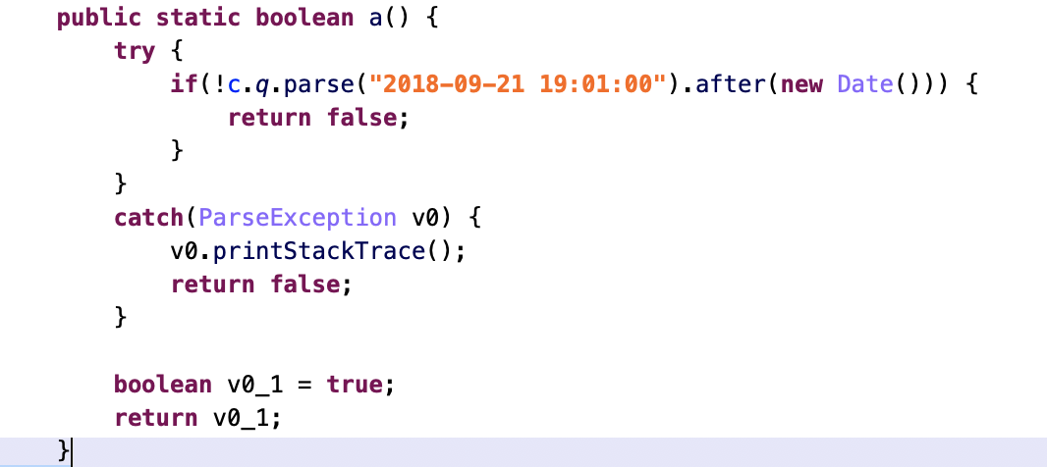

* d7589d6077271a4245cd37592287a434608caed755b54213138f0de254cab059

Same as 3080fa6b0c00dcb34de9ee32dcddc3c0491d3899269af71367e0322cec916787

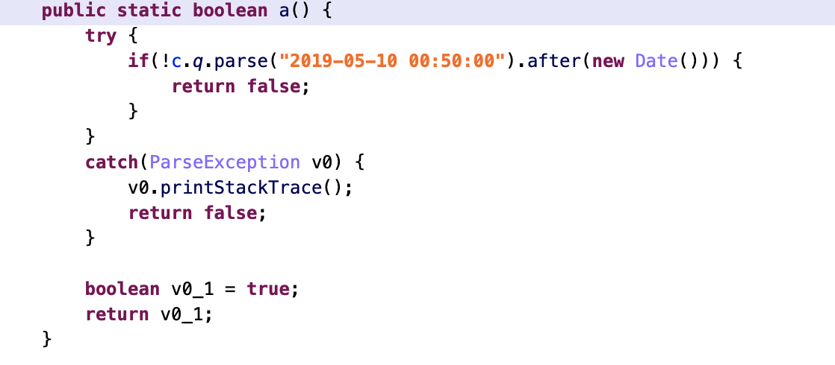

* 4a7c4bd24e70d9fa40f128711e25571103f0970fdefad29b9919c0d4259a17e7

Same as 3080fa6b0c00dcb34de9ee32dcddc3c0491d3899269af71367e0322cec916787

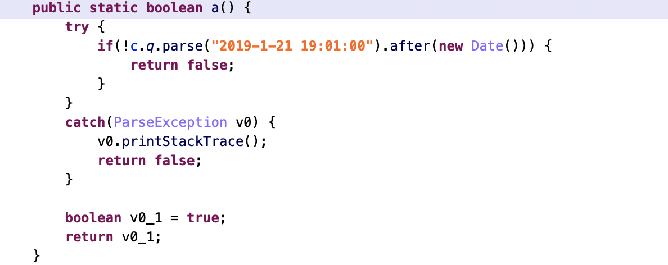

* 2c1a866777bf0220a39baeda6004f079e6a88b7558d21e17f4af2c393076f4bf

Same as 3080fa6b0c00dcb34de9ee32dcddc3c0491d3899269af71367e0322cec916787

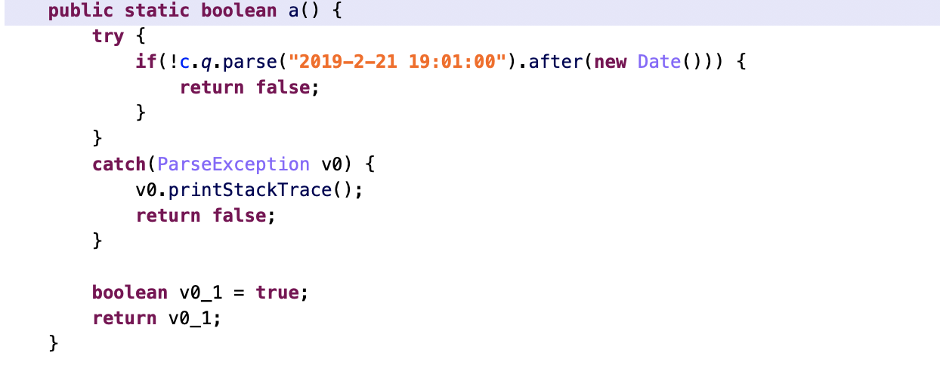

* 8dacf5fb53b4435936d4d8af0ce4bb49a60592f6a1d2c3dc343466abddcf0dea

Same as 3080fa6b0c00dcb34de9ee32dcddc3c0491d3899269af71367e0322cec916787

